# Christmas Cheer Laser, part 9

## Answers to Previous Questions

1. What OS is this terminal runnning?  
   The file system looks like Linux. Check with these two commands.  
   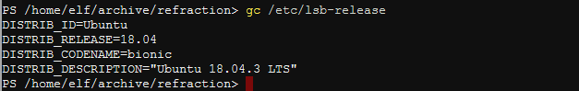  
   Yes, it’s Linux. What does $PSVersionTable have to say?  
   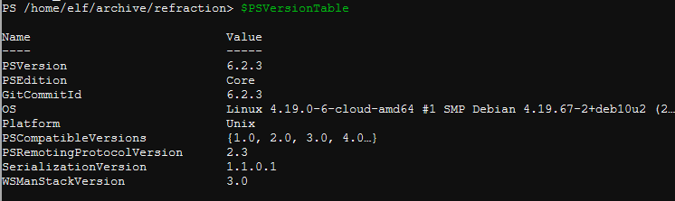  
   PowerShell Core 6.2.3 on Ubuntu 18.04.3
2. How do you run a brand new script/executable in this OS? (If you need a hint look in /bin. The permissions are in Windows format instead of rwx format, but there is still useful information.)  
   In Linux, a script or executable has to have the execute permission, the ‘x’ in ‘rwx’.  
   You normally add that permision with chmod +x filename  
   In /bin, we find that chmod may be available.  
   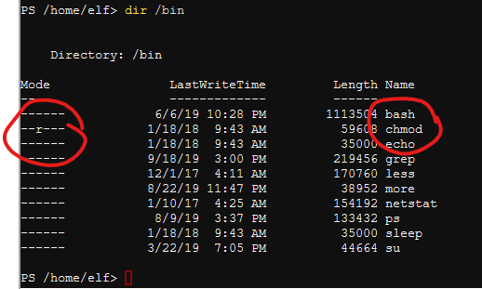
3. What is the value of the last parameter?  
   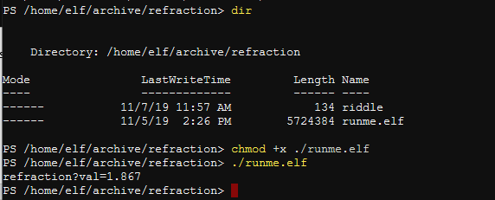  
   chmod +x ./runme.elf  
   ./runme.elf  
   The value of the fourth parameter is refraction?val=1.867.  
   Note: You may have to go back and expand the archive again, sorry.

Use the parameters you’ve found and the API information from  
Invoke-WebRequest -Uri <http://localhost:1225/).RawContent>  
to return the laser to operation. Note: It’s a good idea to turn the laser off, make the changes, then turn the laser on and check status. Also, the gas values are submitted by a POST instead of a GET request.

## Question

What commands did you use to restore the laser to operation?